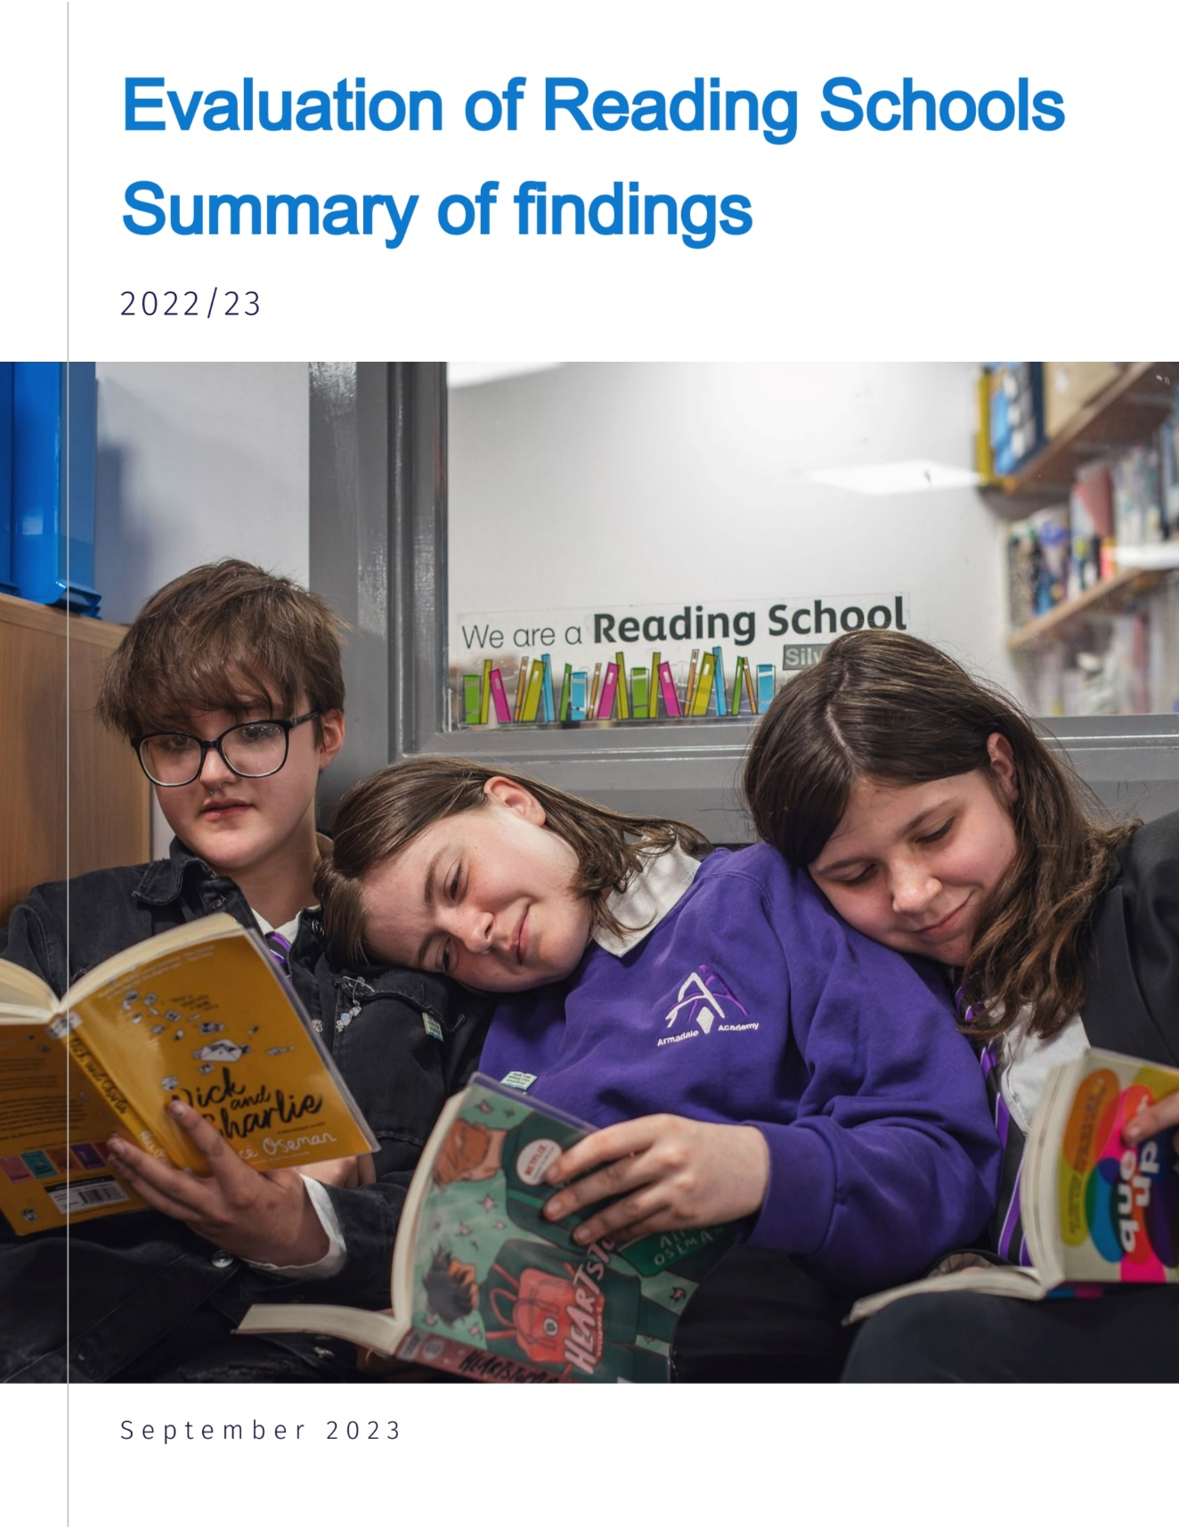

Evaluation of Reading Schools 2022/23 –Summary of findings

About this report

This short report summarises findings from an evaluation of Scottish Book Trust’s Reading Schools programme during 2022/23.

Reading Schools was developed in 2019 and is an accreditation programme that aims to help schools build and sustain a reading culture. Through Reading Schools, schools can gain Core, Silver or Gold accreditation depending on their existing reading for pleasure culture. Schools can choose which level to start with. Since the programme was set up 362 schools have gained accreditation and as of July 23, almost 500 were working towards accreditation. Scottish Book Trust updates participation and accreditation and a map is available online.

Experiences of the programmes

Schools rated Reading Schools highly.
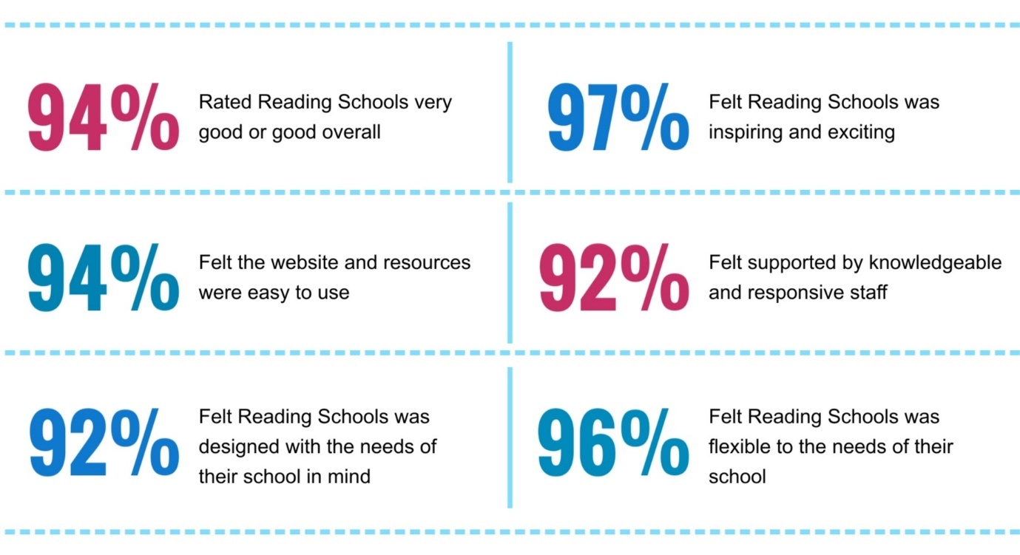

Reading Schools experiences
Schools taking part in Reading Schools were positive about the information and resources on the website, the support received from Scottish Book Trust and the career long professional learning provided as part of the programme. Schools found it very helpful that there were no fixed deadlines for the submission of their Action Plan and evidence, making the process more enjoyable and activities higher quality, due to taking place at a pace which worked for their school.

“Reading Schools recognises the work staff and pupils do already and challenges us to improve.”
Class teacher, primary

“Reading Schools is brilliant. It connects clearly with HGIOS… It provides practical and professional learning… It’s well designed for schools and well structured for getting the message out.” Stakeholder

Although all the schools taking part in this evaluation were very positive about their Reading Schools experience, some suggested potential areas for development including:

- reducing demand for evidence or streamlining requirements
- enhancing processes for uploading and exporting evidence
- building connections between schools taking part in Reading Schools
- providing templates or ideas that can be easily transferred between schools
- simplifying paperwork and action planning wherever possible
- ideas on how small, rural or secondary schools could achieve their journey.

Impact of the programmes

Impact on reading
Schools were very positive about the impact of Reading Schools on reading.
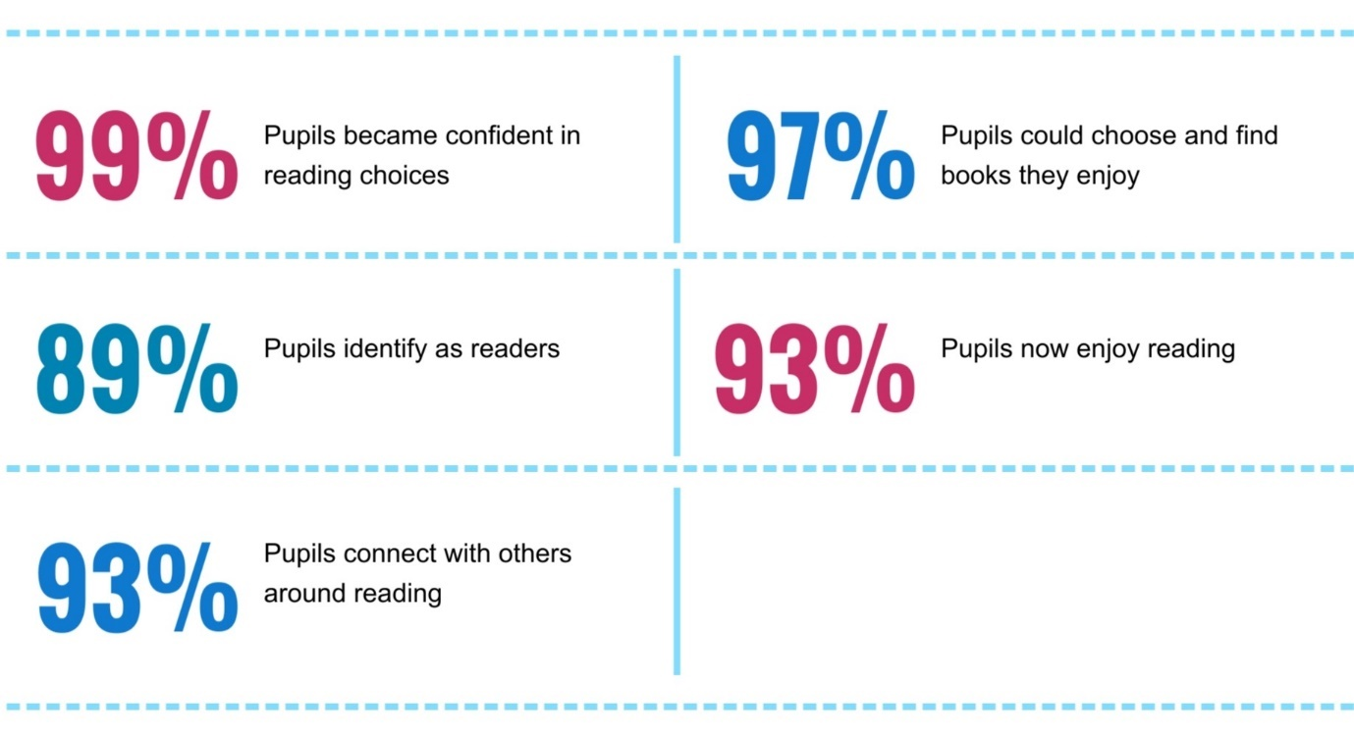

School staff involved in Reading Schools noticed a particular impact on pupils who were not previously enthusiastic readers, with 44% seeing a big increase in levels of reading for pleasure among this group, and 52% seeing a little increase.

Schools taking part in Reading Schools said that the way pupils and staff talked about reading had changed. Many described it as having an enthusiasm, excitement and ‘buzz’ about reading, with pupils seeing reading as fun, not a chore and wanting to read during the school day.

“It’s changed the mindset for a lot of children and they now share a love of reading. That’s the project’s legacy. The impact will be long-term.”
Principal teacher, primary

Impact on learning
Schools felt that Reading Schools had impacted positively on learning and attainment.

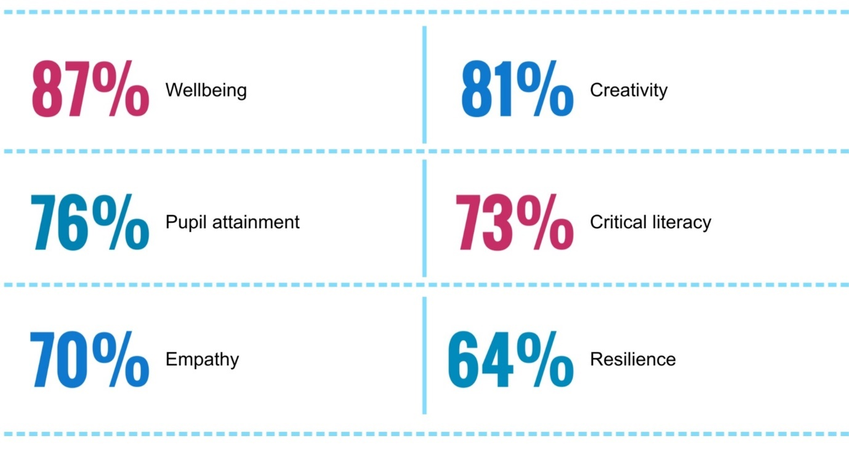

Schools talked in particular about the impact of reading for pleasure in supporting positive wellbeing. Schools highlighted that reading for pleasure provided a calm and peaceful environment for children to regulate their emotions, learn how to express themselves and a have a voice to share their passions. Some were using reading as calm time during or shortly after breaks and lunch, to help pupils to manage their emotions.

“There’s more time for peace and calm within the class.”
Secondary class teacher, ASN school

Some schools said that they had seen improvements in attainment, which could be linked to reading for pleasure through Reading Schools. Schools pointed to improvements in reading, vocabulary, writing, punctuation, critical thinking, emotional literacy, leadership and ownership of learning. A few said that as reading skills and confidence improved this transferred across to other areas of the curriculum.

“We have seen an improvement in our reading attainment across the school and pupils are enjoying reading and choosing to read.” Class teacher, primary

Impact on the school
Schools talked very positively about the impact of Reading Schools on their school. Schools felt that reading had become an important part of their school community, with staff engaged from across the school.

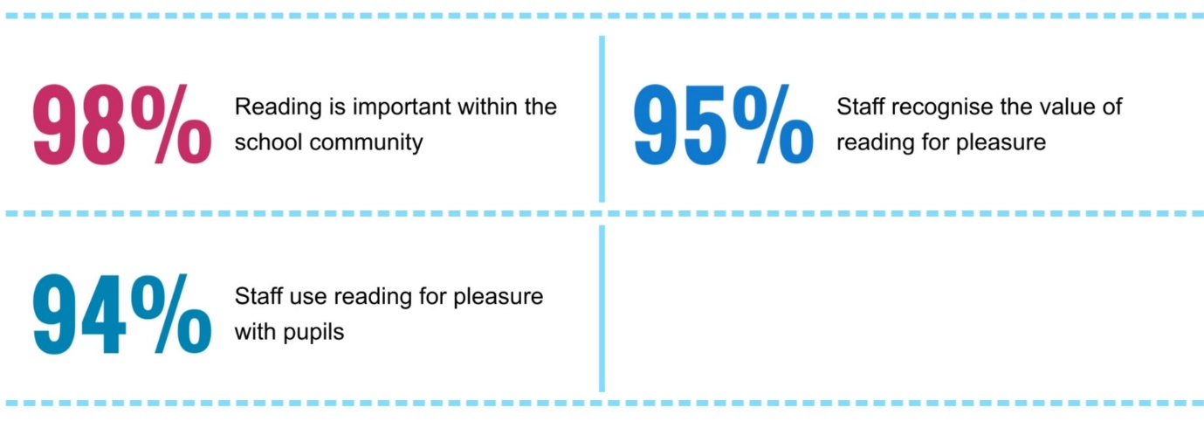

Schools also said that Reading Schools had engaged parents and families and resulted in more conversations with parents about reading. This had increased understanding of the value of reading for pleasure and increased family engagement with the school.

“Family engagement in our school is far better than ever before as a result of the many reading events now being held in school.” Class teacher, primary

Conclusions

Reading Schools is supporting reading, learning, attainment and a culture of reading for pleasure within schools through:

- Making reading fun – supporting confident reading choices, pupils identifying as readers, enjoying reading and connecting with others around reading.
- Learning and attainment – supporting wellbeing, creativity, literacy, empathy and resilience.
- Building a whole-school culture – creating an environment where reading is important within the school community.

Reading Schools has a clear ongoing role in building a whole-school approach to reading for pleasure. With the FMRC programme stopping, Reading Schools may benefit from a softer entry point for schools, to introduce more schools to the Reading Schools programme in an accessible and gentle way.

Schools were very positive about Reading Schools and wanted to continue participating. Through learning from early experiences and tweaking evidence processes, the journey could become more user friendly and less resource intensive, while retaining its value. Building connections between schools, ensuring different types of school can achieve a positive Reading Schools journey and wider awareness raising could all help many more schools achieve benefits for their pupils through Reading Schools.

The resources and connections within the FMRC programme should be built on through the Reading Schools programme. Schools and stakeholders were very positive about the resources available through FMRC and some used these to support their Reading Schools journey. Consideration should be given to including some relevant FMRC resources on the Reading Schools site, or wider SBT site as relevant. Schools taking part in FMRC but not Reading Schools should be proactively supported to transition to their Reading Schools journey, should they wish.

